CREATE TABLE city (

id INT,

city_name VARCHAR(50),

lat DECIMAL(6,2),

longs DECIMAL(6,2),

country_id INT

);

Insert into city

values(1,'Berlin',52.52008,13.404954,1),

(2,'Belgrade',33.417197,20.457273,2),

(3,'zagrab',45.815399,15.966563,3),

(4,'New York',40.730610,73.935242,4),

(5,'Los Angles',34.053522,-118.243683,5),

(6,'Warsaw',52.237049,21.017532,6);

Select * from city;

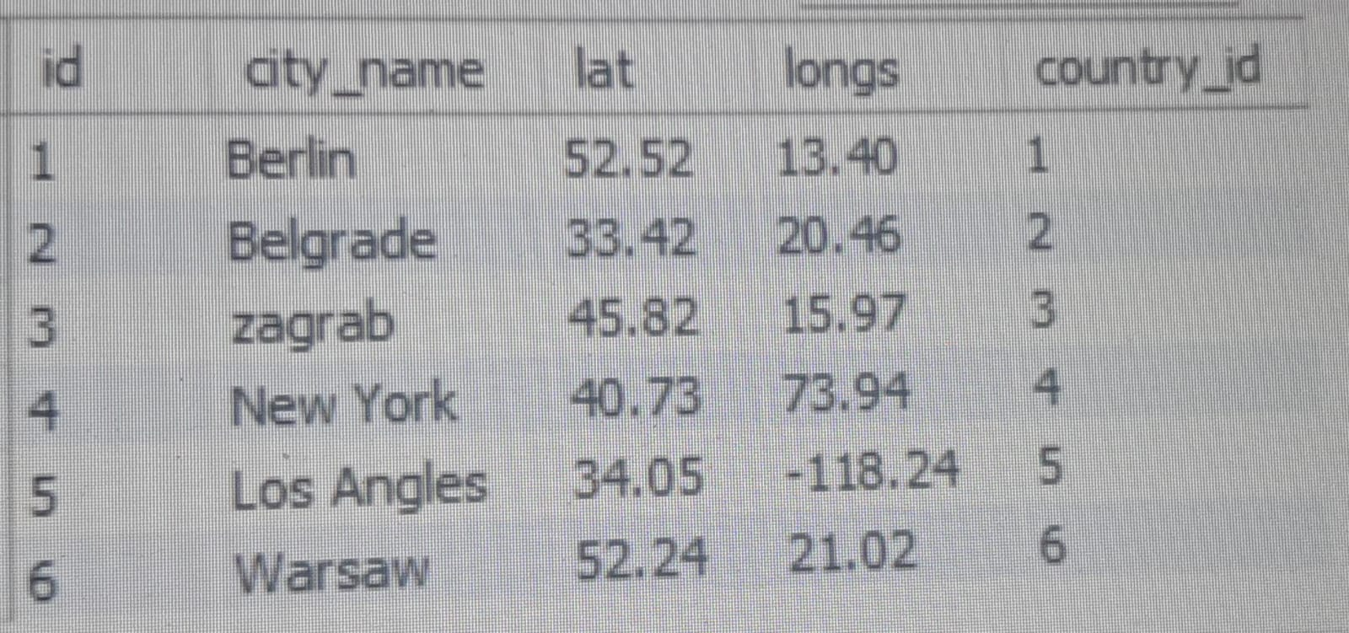

create table customer(

ID int,

customer_name varchar(50),

city_id int,

customer_address varchar(50),

next_cal_date date,

ts_inserted datetime

);

insert into customer (ID,customer_name,city_id,customer_address,next_cal_date,ts_inserted)

values(1, 'Jewelry Store', 4, 'Long Street 120', '2020-01-21', '2020-01-09 14:01:20'),

(2, 'Bakery', 1, 'Kurfürstendamm 25', '2020-02-21', '2020-01-09 17:52:15'),

(3, 'Café', 1, 'Tauentzienstraße 44', '2020-01-21', '2020-01-10 08:02:49'),

(4, 'Restaurant', 3, 'Ulica lipa 15', '2020-01-21', '2020-01-10 09:20:21');

